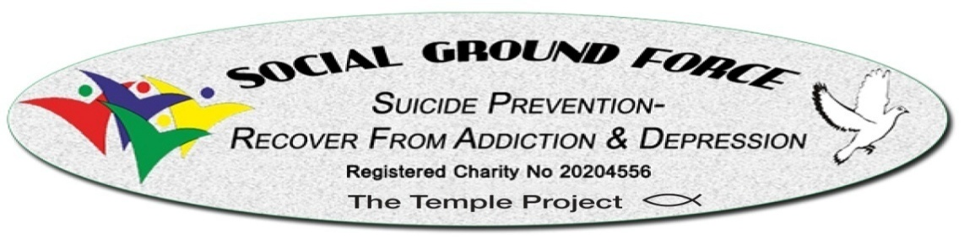
We Save & Change Lives

Social Ground Force 2025
Report On

Suicide Prevention
And
Recovery From
Mental Health Issues Caused by Addiction

January 2026

No 10 The Mall, Sligo, F91 WF70. Company CRN 548570 Tel: 00353 868941991
Website: www.socialgroundforce.com Email: socialgroundforce@yahoo.ie

Table of Contents

- Foreword
- Who are Social Ground Force
- Addiction in Ireland
- Our impact in 2025
- Our Mission
- How do we achieve our outcomes
- The Death Gap
- Alignment with National Strategy
- Testimonials and Partnerships
- Quotes About Our Service From Community
- Success stories
- Funding Request
- Conclusion
- Value for Money
Appendix (i, ii)

Social Ground Force

We Specialise in the Death Gap, We Save & Change Lives

Foreword

The most precious asset of every country is its population, when part of that asset develops an illness which is fatal, then that country is duty bound to save that part of its asset. It must use all its resources in order to achieve a successful outcome for all concerned. This must be done in the most cost effective and efficient manner which will gain that country a long-term solution for all who may come in contact with this illness and ease the burden on the sufferer, their families, communities and society in general.

Social Ground Force (SGF) was created and exists to reduce the number of suicides in Ireland. To provide both immediate and long-term Recovery to those who suffer from suicidal ideation and the disease of addiction— saving and changing lives.

- Who We Are

We are Registered Charity Number 20204556 We deal with Suicide Prevention, Depression and assisting those in recovery and those who wish to recover from: Mental Health Issues caused by Addiction to Alcohol, Drugs, and Gambling. We Are a man management group as each individual is different. We are also a stablising unit, we, guide the service user away from their mind-altering substance environment. Introduce them to another way of life free from their destructive past onto a pathway to recovery.

Important
We offer an alternative service that would complement the existing service which can no longer cope with the volume of Mental Health Cases caused by Addiction and Covid19.

- Suicide prevention
- Stabilisation Unit
- Case Management
- Mental health support
- Addiction recovery (alcohol, drugs, gambling)
- Supporting those in recovery

- Addiction in Ireland

Addiction is a growing problem in Ireland. In 2024, the National Drug Treatment Reporting System (NDTRS) reported 13,295 cases treated for problem drug use (Health Research Board, 2025). The number of cases reported in 2024 was 50% higher than it was in 2017 (Department of Health, 2025).
Cocaine remains Ireland’s most common drug treated, the substance accounts for 40% (5,289 cases) of all drug treatment in 2024(Health Research Board, 2025). Ireland’s addiction services saw a 300% increase in people returning for cocaine treatment from 2017(692 cases) to 2024(2,764 cases).
Addiction has a significant relationship with increased depression rates. There is a high prevalence of depression among those addicted to drugs. However, this prevalence is similar for non-drug addictions (Coelho et al., 2000). Zielinski et al. (2024) found that higher self-reported depression scores significantly predicted higher food addiction (FA) scores (Zielinski et al., 2024).
People struggling with addiction also show a high prevalence of suicidal ideation (Mino et al., 1999). The scientific consensus is that suicidal ideation is significantly correlated with suicide and suicidal behaviour, especially in drug users (Mino et al., 1999). This means that abuse users have a higher prevalence of suicide or attempted suicide than people who aren’t addicted.
Addiction has a significant correlation with increased crime rates; those who suffer from addiction tend to have a high number of criminal convictions (Connolly, 2006). The Irish Prison Service (IPS) estimates that 70% of people who go into prison in Ireland have an addiction or substance abuse problem (Health Research Board, 2025). In Ireland, most drug users who are sentenced to prison are punished, not for drug offences, but for offences committed because of their addiction and drug use (Connolly, 2006). It is safe to say that if addiction rates drop in Ireland, crime rates will consequently drop as well. The IPS budget for 2024 was € 502 million, which is a substantial number of resources allocated to the Irish Prison Service (Irish Prison Service, 2024). Focusing primarily on the restoration of the lives of people struggling with addiction instead of imprisonment could lead to less strain on the IPS. Employing sustainable measures and supports for addiction within Ireland could lead to less crime and in turn, less strain and resource allocation on the IPS.

- Our Impact in 2025

To highlight the mental health challenges presented the following shows the mental health challenges faced by SGF clients last year.
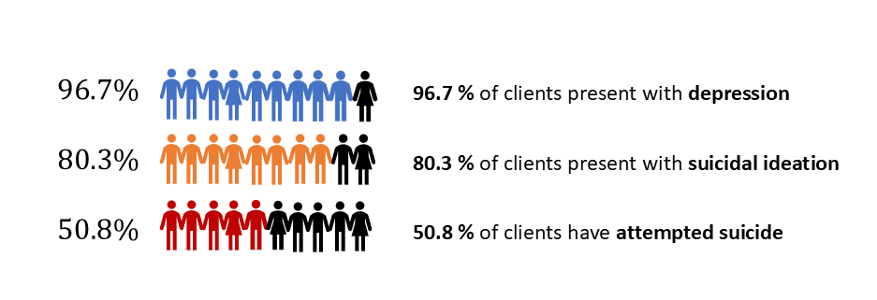
The mental health challenges are further exacerbated by the relationship between addiction and crime. Last year’s data is shown below, which further impacts healthy recovery.

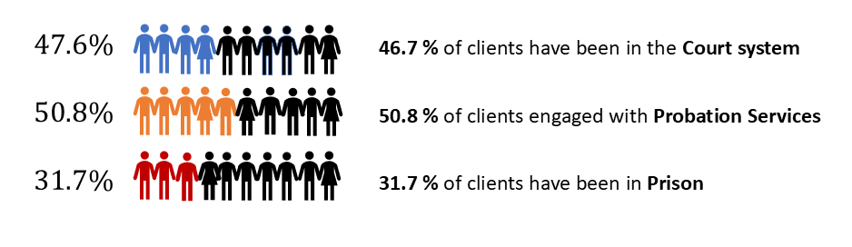
Saving Lives is the core principle and mission statement of Social Ground Force.
- We are proud to confirm that Social Ground Force has been 100% successful in suicide prevention of our 76 service users in 2025.
- 100 % of clients received educational information on the disease of addiction within 48 hours.
- 75% showed measurable recovery improvements.

In 2025, we dealt with 76 service users and their families, which included 105 children.
Among our service users, 69.7% were male and 30.3% were female.
The age of clients ranged from 14 to 69 years, reflecting the wide cross-generational reach of Social Ground Force services.
34.8% of clients were from counties outside Sligo, where Social Ground Force is based, demonstrating a strong regional and cross-county demand for our support.
Notably, 11 clients (16.9%) were experiencing homelessness at the time of engagement, highlighting the high level of vulnerability among those we support.
38.7% (24 people) clients had prior rehabilitation experience.
36.1% (22 people) clients engaged in stable relationships during recovery.

Addiction Profiles
Many clients presented with multiple and overlapping addictions, significantly increasing mental health and suicide risk:
- Alcohol dependency: 93.7% (59 clients)
- Cocaine use: 57.4% (35 clients)
- Prescription drug misuse: 57.4% (35 clients)
- Cannabis / hash / weed: 44.3% (27 clients)
- Benzodiazepines: 23% (14 clients)
- Gambling addiction: 20.3% (12 clients)
- Heroin use: 4.9% (3 clients)

Highlights of August – November 2025

- Recover Club, Sligo (in development): SGF began building a new recovery and education hub to support people post-rehabilitation through training, peer groups, and mentoring.
- HSE engagement: SGF CEO Aubrey Melville held an official meeting with HSE representatives, who expressed strong interest in collaboration. In October (two weeks), SGF referred 9 people to rehabilitation and supported many more — without State funding.
- Media & awareness: Aubrey Melville spoke live on Midwest Radio 96.1 FM, sharing verified suicide prevention outcomes and recovery stories.
- Youth for Life – student action: At TUS Midlands Athlone, a student-led charity event raised funds for SGF’s Suicide Prevention Network.
- Community expansion (Co. Mayo): After a presentation at Killasser Community Centre, 40+ people attended and 7 participants began training as peer-support specialists.
- National Network growth: Stage 1 is underway, linking communities in Sligo, Mayo, Leitrim, Galway, Donegal, Athlone, and Limerick.

Our activities, progress and achievements can be clearly seen in the photographs provided in the Appendices i - ii.

5. Our Mission

We aim to reduce suicide numbers in Ireland caused by mental health issues related to addiction of alcohol, drugs, and gambling. Ultimately, to grow and spread across the country, giving our service in every county. The larger the support available, the shorter the death gap, which leads to fewer suicides a year. We aim to relieve the burden on the public health sector. We see a future where people suffering from this disease are thoroughly supported and cared for. The majority of diseases that can result in death get the attention they deserve, and the people who suffer are supported in Ireland; we want addiction to be on the same level.

- How do we achieve this outcome?

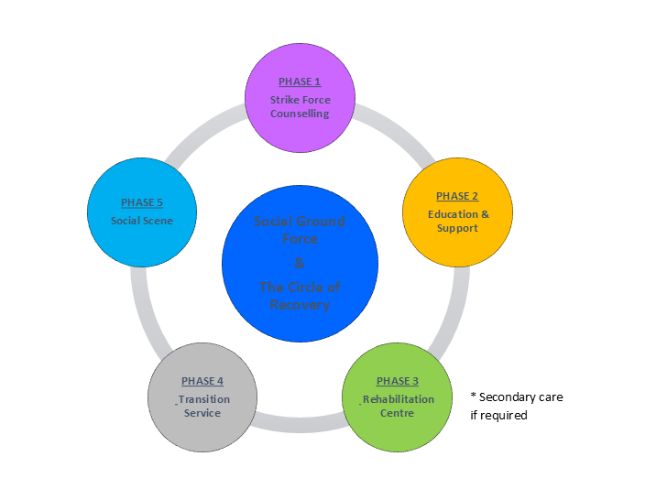

Phase 1 Strike Force Counselling.
At the request from client, family or friend, SGF will drop into their lives, extract them from danger and place them on a pathway free from mind altering substances. As part of this program, we will train our own counsellors.

Phase 2 Education and Support.
Basic knowledge of disease, guide and support. Assistance if required with Courts, Probation Services, medical appointments, self-help Groups, transport to rehabilitation centres and other services if necessary. even within the prison system members can contact Social Ground Force if they are struggling mentally in prison, and much more.

Phase 3. Rehabilitation Centre.
Facilitate suffers entry into Rehabilitation centres if required or enter into long term treatment in another jurisdiction.

Phase 4. Transition Service.
Safe environment creates continuity of recovery, creating an environment where there is safety, stability and security if possible. Now we have our own centre this can be a part of the day where service users, if clean and sober can spend time and recreate their lives.

Phase 5. Social Scene.
As the majority of addicts have lost their social skills and burned all bridges, this progress will assist the client to reconstruct a new life in a substance free world – meeting, conventions, dancing, swimming, walking, cycling, gardening etc.

- The Death Gap

Sufferers and their families in Ireland suffering from mental health issues caused by addiction often face dangerous delays in receiving any sort of immediate care, especially residential care. We call this the Death Gap. This span of time is recognised by the HSE and other frontline workers. Social Ground Force responds immediately to fill that gap and prevent unnecessary loss of life, and violence especially domestic violence.

- Alignment with National Strategy

Our work directly supports all of the 5 strategic goals of Ireland’s “Reducing Harm, Supporting Recovery” National Strategy 2017 / 2025:

1. Promote and protect health and wellbeing.
2. Minimise the harms caused by the use and misuse of substances and promote rehabilitation and recovery.
3. Address the harms of drug markets and reduce access to drugs for harmful use.
4. Support participation of individuals, families and communities.
5. Develop sound and comprehensive evidence-informed policies and actions.

- Testimonials and Partnerships

We work closely with Ireland’s Probation Service, local Solicitors, Barristers, Gardai, Judges, HSE, TUSLA, and community organisations to provide wraparound care. Our services are increasingly called upon where State structures are overwhelmed or unavailable.

By the fact that we have the testimony of the Probation Service of Ireland stating that we are considered by them as a special force in the fight against suicide in Ireland, indicates to us that we are meeting our objective.

This is confirmed by members of the legal profession and members of the prison service in their testimonies, by family members and sufferers themselves who would say that if it was not for Social Ground Force I may not be here now.

- Quotes About Our Service From Experts

Gordon Barrett, Team Leader, HSE:
“Thank you very much for all your advice and input into the case of the young man who was a recent patient of Sligo Regional Hospital. The direct work that you did with him and his family, as well as the arrangements that you were able to make to give him the opportunity of getting on an Addiction Treatment Program were most valuable to him and a tremendous assistance to our Department in trying to meet his needs in a very short time span. The best of luck with your continued endeavours.”
Marc Mac Sharry, TD:
“I know Aubrey Melville, CEO of Social Ground Force for many years and have witnessed first hand the great work that his organisation does to assist those with issues with alcohol, drugs and gambling across County Sligo.
Social Ground Force also provides a range of phone supports to help all their clients including Suicide Prevention, Recovery from Addiction and Depression.
With the numbers who have addiction issues on the increase, never was there such a need for this service to assist individuals in addiction and their families on the road to recovery.
I strongly support this organisation for funding, and I believe that it is money well spent in terms of the work and services that it provides.”

Bridget Myles, Probation officer:
“If I had to describe Social Ground Force in a couple of sentences it would be, they are like ‘Special Forces’ they parachute in when there is an emergency, rescue, educate, and support recovery. In my opinion, if this service was properly funded, it could do so much more and could be replicated across the whole country. I would encourage and support any application for funding and believe it would be money well spent and in the long term would save the state an absolute fortune”.
She identified the importance of education in the whole process specifically “Education of clients and members of the public on the root causes of addiction and it’s relationship to mental health and crime”.

Gerard Mc Govern, Solicitor:

“As a Solicitor practicing in the West of Ireland, I am writing to you to confirm that as a member of the Legal Profession who comes into contact with these poor unfortunate people who suffer Mental Health conditions caused by their addiction in the District Court/Circuit Court, that I fully support Social Ground Force. I understand that they also have the backing of a number of fellow solicitors practicing in Sligo.
Our local Judge, Judge Kilrane has praised this organization on a number of occasions for the work they carry out for these poor unfortunate people and for the rapid response they provided at a time of crisis.”

Tom Mac Sharry, Solicitor:

“In relation to the above, in my capacity as a Solicitor I have witnessed firsthand the Fantastic and invaluable work that has been carried out by Social Ground Force in helping individuals, families and indeed the community in general who have been affected or touched by addiction in all of its forms. The benefits of this service to all of the above are unique and in most cases successful in their approach to mental health issues caused by addiction. This is a vital service, and I would recommend all and any support including financial support which can be given to keep Social Ground Force in operation.
Social Ground Force is an essential life saving service and it is extremely accessible to its service users as there is no appointment needed and it offers an immediate response to any one who is seeking help whether it is for themselves or for advice, help and guidance for a family member or a loved one who is in the grip of an addiction. Addiction is known as the 'Family Disease' as it has a ripple effect which spreads through families and creates untold and numerous problems, this service reaches out to the family members also and helps them to cope. There is no waiting list to be seen by the service which is phenomenal and in a lot of cases can mean the difference between life and death.”
Martin J. Burke, Solicitor:

“We refer to the above matter and write the within in support of the organisation Social Ground Force and its Managing Director Mr. Aubrey Melville.
Our firm is a general practice legal firm operating in the region of Longford, Leitrim, Roscommon, Sligo, Donegal and Cavan. A large proportion of our legal work is in the area of criminal defence, and we continually encounter persons who are suffering from or dealing with addiction issues. We have seen many persons who, because of their unresolved addiction issues repeatedly come before the Courts and in some cases end up in prison or deceased. This obviously results in a substantial demand on State resources in payment for Gardai, Judges, Solicitors, Courts staff, Probation officers, etc and it would appear to us that if an alternative approach to addiction in this country was adopted many savings could be made. From our experience in dealing with many persons prosecuted for criminal offences sufficient resources do not seem to be available to enable to help them effect real change in their behaviours and deal with their addiction issues in a sustainable way.
During the course of representing defendants in the criminal courts we have encountered Mr. Melville’s organisation Social Ground Force a number of times. We have observed the manner in which Mr. Melville monitors persons who are engaging with his organisation and how both he and his team maintain regular contact to ensure the service users are managing their daily life challenges in an appropriate way. We have seen service users of Social Ground Force greatly improve their lives because of the supports provided by this organisation. We have also seen our local District Court Judge Kevin Kilrane encourage defendants to continue to engage with the organisation which is assisting them.
We would have no hesitation in recommending Social Ground Force to clients who are dealing with addiction issues. The innovative approach of the organisation appears to be extremely effective, and we would hope that the organisation can secure any supports which may be available to it in order to continue its work.”

- Success stories
“I met up with Aubrey from Social Ground Force; he showed me the reason for my relapse and the way to stay clean and sober. I am now ten months sober again. Mr Aubrey Melville is CEO of SGF and professional addiction Counsellor. His work in court system all over Ireland, advocating for those who suffer from the disease of addiction and their families. His expertise in the disease of addiction has given me the pathway forward in my life. The knowledge I am now gaining from Social Ground Force is what I have been looking for all my life. A pathway to peace and happiness, free from mind altering substances with my children”. – Megan, client
“In 2015 I hit my bottom and ended up in mental ward drying out, but after that I met with Aubrey from Social Ground Force. He saved me and gave my husband back his best friend, lover and mother to his child. I have now been sober 5 months. I was told that my life would change in ways a couldn’t image! Well in such a short time I have found happiness and laughter I had lost. I have become a better mummy to my son; I am not just doing for him what is needed I am growing up with him and taking in everything he does with new sober eyes. Thank you Social Ground Force the Club Sligo, my family and my friends”. – Dianne, client
In his appearance on TV channel RTE One Bernard O’Hehir said:
“You had to be so many weeks clean and yet go through all these assessments. And I ended up basically begging, just please take me, because if it went on another day or two, I was dead. And that`s not exaggerating. It was it really bad at that stage. So I was going to this place called Social Ground Force in Sligo from by a guy called Aubrey Melville to help people with addictions and mental health and that. So I was going there.”
Bernard O’Hehir faced a life of struggle, homelessness and addiction — then he turned it around and published an uplifting book “Memories And Hope”.

12. Funding Request

Social Ground Force currently receives no state subsidies, funding or private sector support. It is run on a 24/7 voluntary basis through a public / client donations policy. But demand is increasing.

Any Donations are appreciated and much needed.
We seek funding to:

• Expand the Recovery Circle Program
• Employ two full time staff and two part time staff
• Launch a national educational outreach program
• Establish a 24/7 crisis response service

13. Conclusion

Social Ground Force has achieved proven results since its inception in 2014. Anyone with a clear and open mind can see that addiction is a very complicated issue, but there is a simple solution. From a mental health point of view, it is a clear success for most of the participants and their families. Financially It has been suggested to us that, from an absolute minimum Social Ground Force has saved the state around €15 000 000.00 last year alone. Multiply this by 26 Counties and you get €390 000 000.00. These figures will be said by some as insane; this could not be true, and the reality is that we can make it true. The problem is the status quo will not let go of control; for them, it is not about saving lives, it’s about being in control (If you always do what you always done, you will always get what you always got).

It will take a government with an understanding and empathy towards its constituents, those who suffer from this horrible condition that causes so much pain and heartache. Costing families their loved ones, domestic violence and abuse, and criminality. This, in turn, is financially draining invaluable funds from health issues that truly need vast amounts of funding. Addiction does not require a lot of funding; what it does need is the right people getting access to what is required in their counties. Services that are on the true front line of addiction, not Quangos that rehash the same worded documents year after year. This is not what is required; what is required in hardcore addiction is people who have walked the walk and can talk the talk. This generates respect from the sufferers, and they become more inclined to respond to their peers. With financial backing, we can significantly reduce suicide rates, support recovery, and change the national approach to mental health and addiction.

In 2025, we dealt with 76 service users and their families, which included 105 children.

This is a family disease, because their loved ones are in chaos because of addiction, which in turn reverts back to the family home. Most families with addicted loved ones end up on some form of prescribed medication, creating more addiction and mental health issues.

We are proud to say we were 100 % successful, as we never lost anyone to suicide.
Our recovery success medium to long-term rate is around 45%. This is without funding.

14. Value for money

15%n of €390,000,000.00 is €58,000,000.00. This pays for itself.

The cost-effectiveness of this service and the burden it will alleviate from society and families is without doubt a cost that should not have to be debated. We save and change lives.

Your support can help us close the death gap— and save lives.

Author: Aubrey Melville
CEO, BA (Hons) Counselling / Addiction

References

Coelho, R., Rangel, R., Ramos, E., Martins, A., Prata, J., & Barros, H. (2000). Depression and the severity of substance abuse. Psychopathology, 33(3), 103-109.

Connolly, J. (2006). Drugs and crime in Ireland. Dublin: Health Research Board.

Department of Health (2025, May 28). Minister for Public Health, Wellbeing, and the National Drugs Strategy highlights increased provision of drug treatment services. Gov.ie. Retrieved January 16, 2026, from https://www.gov.ie/en/department-of-health/press-releases/minister-for-public-health-wellbeing-and-the-national-drugs-strategy-highlights-increased-provision-of-drug-treatment-services-2/

Health Research Board (2025, March 10). Focal Point Ireland National report for 2024-Prison. Www.Drugsandalcohol.ie. Retrieved January 19, 2026, from https://www.drugsandalcohol.ie/25265/

Health Research Board (2025, May 28). National Drug Treatment Reporting System: 2024 drug treatment demand. Drugsandalcohol.ie. Retrieved January 16, 2026, from https://www.drugsandalcohol.ie/38474/

Irish Prison Service. (2024). Annual Report 2024. Dublin: Irish Prison Service. Available at: IPS-Annual-Report-2024.pdf

Mino, A., Bousquet, A., & Broers, B. (1999). Substance abuse and drug-related death, suicidal ideation, and suicide: a review. Crisis: The journal of crisis intervention and suicide prevention, 20(1), 28.

Zielińska, M., Łuszczki, E., Bartosiewicz, A., Oleksy, Ł., Stolarczyk, A., & Dereń, K. (2024). Relationship Between BMI, Self‐Rated Depression, and Food Addiction—A Cross‐Sectional Study of Adults in Postpandemic Poland. Depression and Anxiety, 2024(1), 5563257. https://doi.org/10.1155/2024/5563257

